The required artifacts:

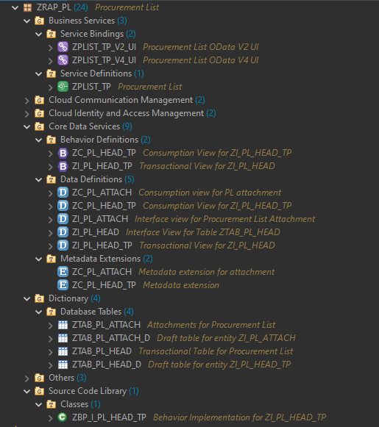

Preview Screenshots:

First page:

Object Page:

Plate number validation during save (It will allow in draft mode though):

Action button to Update Status:



